# AWS EC2 TASKS

1. Launch one EC2 using Amazon Linux 2 image and add a script in user data to install Apache.

* Go to **EC2 → Instances → Launch instance**.
* Keep the default **Security Group**

* Add script in user data

* Check status by using sudo systemctl status command

* Run the public id in browser.

1. Launch one EC2 using Ubuntu image and add a script in user data to install Nginx.

* Go to **EC2 → Instances → Launch instance**.
* Keep the default **Security Group**
* Add script in user data

* Check the status.

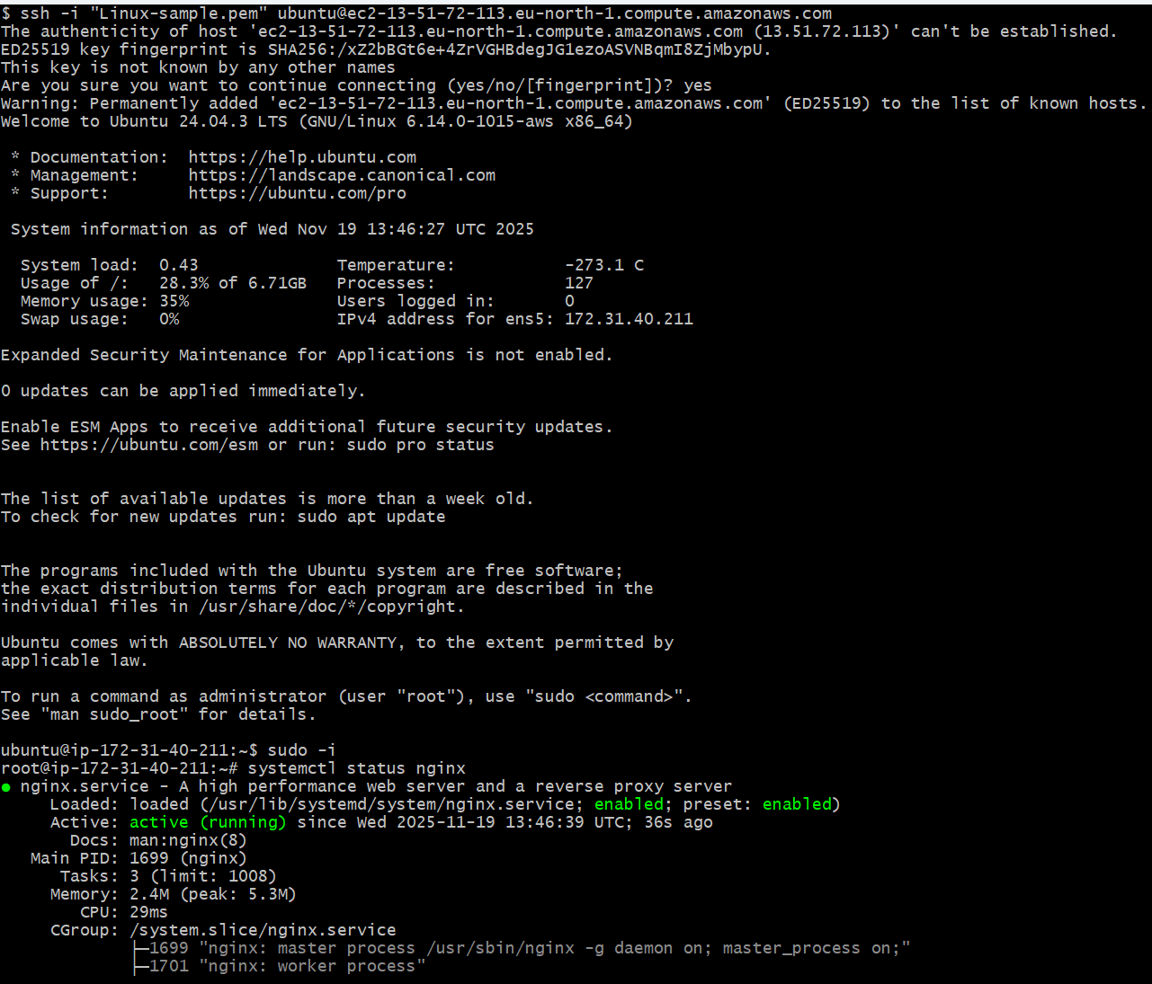

1. Launch one Windows server and install Tomcat on Windows.

* **Launch the EC2 Instance**
* . Open the AWS Management Console.
* Launch a new EC2 instance and name it **windows-server**.
* Select a **Windows AMI**
* Choose an instance type
* Select **Default Security Groups**.
* Review and launch the instance.
* **Connect to Windows via RDP**
* After the instance starts, go to the **Connect** button.
* In the **RDP Client** tab, click **Download Remote Desktop File**.
* Next, click on **Get Password**.
* Upload your **.pem key file** or paste the contents of your key into the **Private Key Contents** box.
* Click **Decrypt Password** to get the **Administrator password**.
* Use the RDP file and password to log in to your Windows server.
* **Install Apache Tomcat and Java**
* Once connected to Windows, open a browser.
* Download **Apache Tomcat version 9** from the official Tomcat website.
* Download and install **Java JDK**, which is required for Tomcat.
* After installing Java, run the **Apache Tomcat installer**.
* Complete the installation steps and start the Tomcat service.
* **Verify Apache Tomcat**
* Open a browser on the Windows server.
* Go to:
* http://localhost:8080

Click to Get password

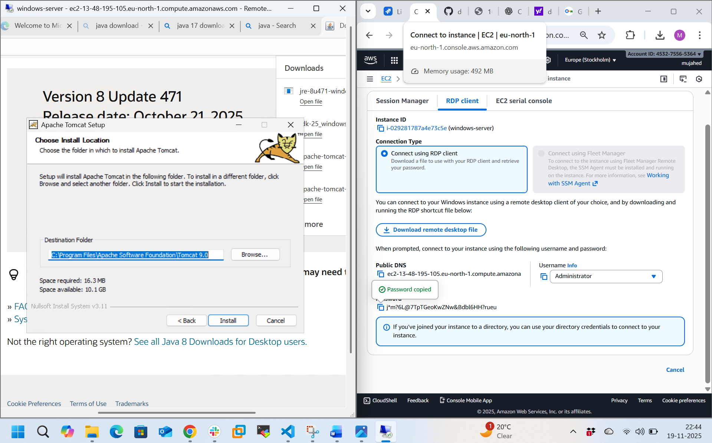

1. Take a snapshot of the instance created in Task 1.

**Step 1: Go to EC2 Instances**

* From the AWS console, open **EC2 Dashboard** → **Instances**

**Step 2: Select the Instance**

* Tick/select the instance you want to back up.  
  Example: **apache-httpd** instance.

**Step 3: Open the Actions Menu**

* Click **Actions** (top-right).
* Navigate to:  
  **Image and templates → Create image**

**Step 4: Fill Image Details**

You will see a **Create Image** page.

* **Image name:**  
  Example → apache-httpd-backup
* **Description (optional):**  
  Example → backup
* **Reboot instance:**
  + Leave it **checked** → ensures consistent backup
  + If you do not want downtime, uncheck it

**Step 5: Create Image**

* Click **Create image** at bottom right.

**Step 6: AMI Creation Process**

* Go to **EC2 → Images → AMIs**.
* You will see your AMI in status:  
  **pending → available**

Once status becomes **available**, your AMI backup is ready

1. Assign passwordless authentication for the EC2 created in Task 2.

* Retrieve Your Public Key
* Connect to the EC2 Instance (Temporarily with the .pem file)
* Open the authorized_keys file for Editing
* Insert Your Public Key
* Disconnect and Test the New Login
* Now, try connecting again **without specifying the .pem file**

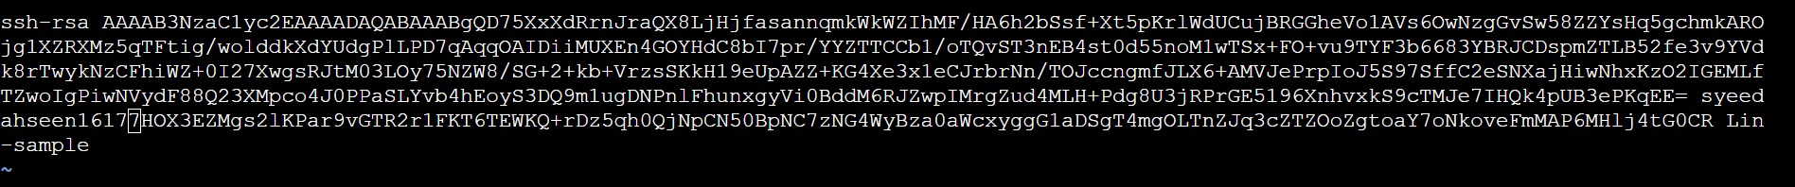

1. Launch any EC2 using the spot purchasing option.

* Go to ec2 dashboard and in spot instance options select no maximum price
* Give default security groups and key pair
* Launch the instance in lifecycle details you will see spot

1. Enable termination policy on the EC2 created in Task 2.

* Go to the AWS Management Console and navigate to the EC2 dashboard.
* In the left sidebar, click on "Instances" to list all your EC2 instances.
* Select the instance you want to protect from accidental termination
* Click on the "Actions" button on the top right above the instance list.
* From the dropdown menu, choose "Instance settings" and then select "Change termination protection".
* In the pop-up window, check the box to "Enable" termination protection.
* Click the "Save" button to apply the change.

1. Launch one EC2 using AWS CLI.

* Launch instance name with aws
* And connect to the server then
* Wget download cli <https://awscli.amazonaws.com/AWSCLIV2.msi>
* Then gave a command of aws configure it will show up a options like
* Access key
* Secret access key
* Region and format

For access key and secret key open our profile then security  
credentials and it will generate the keys Then aws ec2 describe-instances.

